Naomi Almero
Enhancement One: Software Design/Engineering Narrative
The artifact I chose for the Software Design and Engineering category is my original JolliBank C++ program, created in December 2022 for an introductory programming course. The original program allowed a user to choose between a checking or savings account, then perform basic actions such as depositing money, withdrawing funds (including a “withdraw check” option for checking), and displaying a balance. While the program was functional, most of the logic was implemented in a single file with direct cin input and minimal defensive checks. The design also mixed responsibilities (user identity, account data, transaction rules, and the menu UI) in the same flow, which made the program harder to maintain, test, and extend.
I selected this artifact because it clearly demonstrates how applying software engineering principles can transform a basic console program into a more professional, secure, and maintainable application. For my enhancement, I rebuilt the code using a modular, object-oriented design with separate headers and source files, including Authentication, User, BankAccount, CheckingAccount, SavingsAccount, and UserAccounts. This refactor introduced cleaner separation of concerns: authentication is handled independently from account operations, and account behavior is encapsulated inside classes rather than being spread across large menu blocks.
A major improvement in the enhanced version is the introduction of authentication and access control. Instead of immediately allowing account access after entering a name and account number, the new system requires a valid username/password login using authenticateUser(), followed by a PIN verification using verifyPIN(). Both processes enforce a maximum of three attempts, after which the program exits. This design helps protect account access by limiting brute-force attempts and ensuring a user must pass authentication checks before any financial actions are available.
The enhancement also strengthened input validation and defensive programming. In the original program, menu selections and transaction amounts were read directly with cin without consistent handling of invalid input types. In the enhanced version, the main menu and submenus validate numeric and recover from invalid entries using cin.clear() and cin.ignore() via a dedicated clearInput() function. This prevents the application from getting stuck in a failed input state and improves usability by allowing users to re-enter valid options.
For transaction rules and validation, the enhanced version centralizes logic within account classes. The base BankAccount class enforces basic constraints: deposits only apply when the amount is positive, and withdrawals fail if the amount is non-positive or exceeds the available balance. On top of this, the CheckingAccount class overrides withdraw() to enforce a minimum balance rule by preventing withdrawals that would drop the balance below $50, displaying a clear message when the rule blocks a transaction. Similarly, SavingsAccount overrides withdrawal logic to prevent withdrawals when funds are insufficient. Compared to the original version, where withdrawal rules were embedded inside the menu workflow and inconsistently applied, this approach is more maintainable and easier to extend because business rules live with the account types they govern.
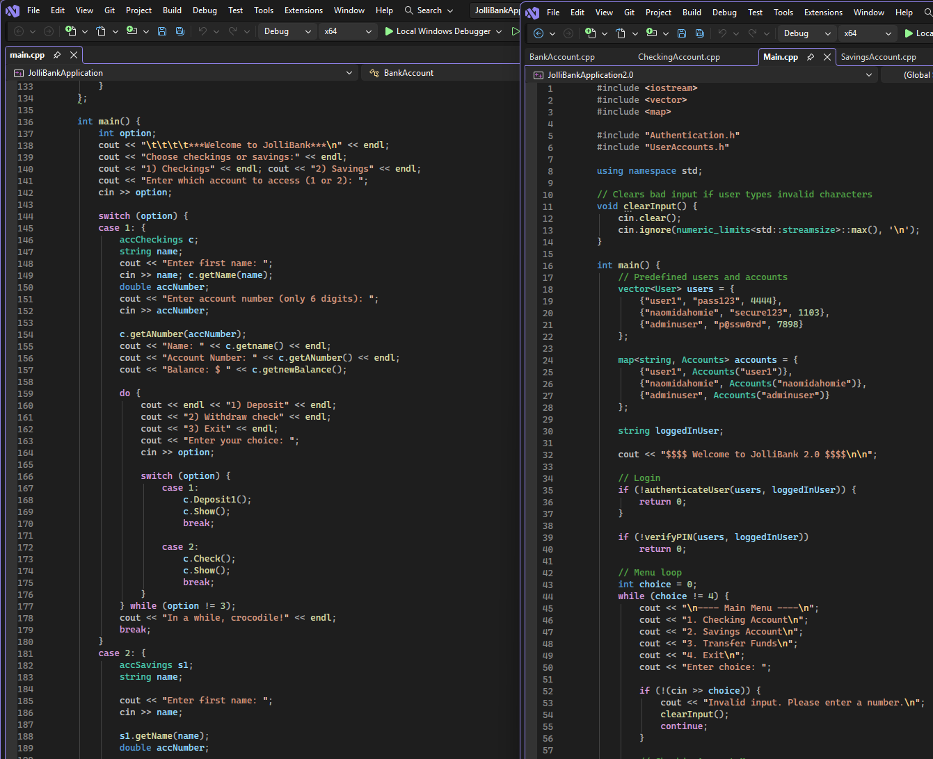
This enhancement supports the course outcome I targeted in Module One by demonstrating my ability to redesign, refactor, and improve software using professional engineering standards. I improved maintainability by separating functionality into reusable classes, improved correctness by centralizing transaction constraints, and improved security by requiring login and PIN verification before account access. No updates to my outcome-coverage plan were necessary, as this enhancement fully addressed the outcome originally identified in Module One. One challenge during development was balancing stronger validation with a smooth user experience, especially handling invalid non-numeric input without crashing or forcing a restart. Implementing structured input recovery and moving transaction rules into overridden class methods reinforced the value of defensive programming and clean architecture decisions.
The included screenshot illustrates the transformation from a monolithic, single-file implementation into a modular design with separate headers and source files. It highlights how the enhanced version uses object-oriented structure, authentication workflows, and validation logic to deliver a more secure and professionally engineered application while preserving the original project’s core banking functionality.

